**Part 64 - C# Tutorial - How and where are indexers used in .net**

**In this video we will discuss about**  
**1.** Where are indexers used in .NET  
**2.** What are indexers in c#

**Where are indexers used in .NET**  
To store or retrieve data from session state or application state variables, we use **indexers**.  
// Using the string indexer to store session data  
Session["Session1"] = "Session 1 Data";  
// Using the string indexer to store session data  
Session["Session2"] = "Session 2 Data";  
  
// Using the integral indexer to retrieve data   
Response.Write("Session 1 Data = " + Session[0].ToString());  
Response.Write("<br/>");  
// Using the string indexer to retrieve data   
Response.Write("Session 2 Data = " + Session["Session2"].ToString());  
  
If you view the metadata of HttpSessionState class, you can see that there is an **integral** and **string indexer** defined. We use "this" keyword to create indexers in c#. We will discuss about creating indexers in our next video session.

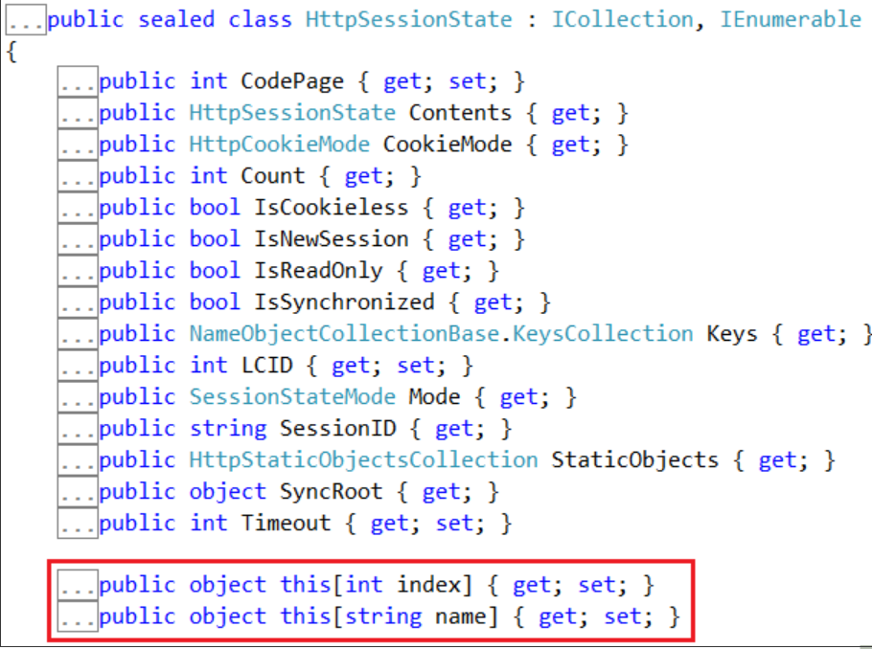

**Another example of indexers usage in .NET**. To retrieve data from a specific column when looping thru "SqlDataReader" object, we can use either the integral indexer or string indexer.  
string CS = ConfigurationManager.ConnectionStrings["DBCS"].ConnectionString;  
using (SqlConnection con = new SqlConnection(CS))  
{  
    SqlCommand cmd = new SqlCommand("Select * from tblEmployee", con);  
    con.Open();  
    SqlDataReader rdr = cmd.ExecuteReader();  
    while (rdr.Read())  
    {  
        // Using integral indexer to retrieve Id column value  
        Response.Write("Id = " + rdr[0].ToString() + " ");  
        // Using string indexer to retrieve Id column value  
        Response.Write("Name = " + rdr["Name"].ToString());  
        Response.Write("<br/>");  
    }  
}  
  
Right click on **SqlDataReader**class and select **"Go To Definition"**, to view it's metadata. Notice that, there is an **integral and string** indexer defined.

**What are indexers in c#?**  
From the above examples, it should be clear that, Indexers allow instances of a class to be indexed just like arrays.  
  
In our next video, we will discuss about creating indexers.